A Mini Project Report
On
WHEELERS DOCTOR
Submitted in partial fulfillment of the
Requirements for the award of degree of
Bachelor of Technology
In
Computer Science and Engineering
by
K. Abhishek Shetty-14H61A0579
Preeti Padal-14H61A05A3
Shravan Kumar-13H61A05F7
Kunal Rathod-13H61A0538
Under the Guidance of
Mr.V.Amarnadh
Asst.Professor


ANURAG GROUP OF INSTITUTIONS
(Formerly CVSR College of Engineering)
(An Autonomous Institution,Approved by AICTE and NBA Accredited)
Venkatapur (V), Ghatkesar (M), RR Dist., T.S-500088
(2014-2018)
Department of Computer Science and Engineering



CERTIFICATE

This is to certify that the project entitled “Wheelers Doctor” being submitted by K. Abhishek Shetty bearing the Hall Ticket number 14H61A0579, Preeti Padal bearing the Hall Ticket number 14H61A05A3, Shravan Kumar bearing the Hall Ticket number 13H61A05F7 and Kunal Rathod bearing the Hall Ticket number 13H61A0538 in partial fulfillment of the requirements for the award of the degree of the Bachelor of Technology in Computer Science and Engineering to Anurag Group of Institutions (Formerly CVSR College of Engineering) is a record of bonafide work carried out by them under my guidance and supervision from July 2017 to Oct 2017.
The results presented in this project have been verified and found to be satisfactory. The results embodied in this project report have not been submitted to any other University for the award of any other degree or diploma.

Internal Guide External Examiner
Mr.V.Amarnadh
Asst.Professor

Mr.Pallam Ravi
Project Coordinator
Asst.Professor

Dr.G.Vishnu Moorthy,
Professor and Head, Dept. of CSE

ACKNOWLEDGEMENT

It is our privilege and pleasure to express profound sense of respect, gratitude and indebtedness to our guide Mr.V.Amarnadh, Asst.Professor, Department of Computer Science and Engineering, Anurag Group of Institutions (Formerly CVSR College of Engineering), for their indefatigable inspiration, guidance, cogent discussion, constructive criticisms and encouragement throughout this dissertation work.
We express our sincere gratitude to Dr. G.Vishnu Moorthy, Professor and Head, Department of Computer Science and Engineering, Anurag Group of Institutions (Formerly CVSR College of Engineering), for his suggestions, motivations and co-operation for the successful completion of the work.
We extend our sincere thanks to Dr.K.S.Rao, Director,Dr.V.Vijaya Kumar, Dean, Dept. of CSE & IT, Anurag Group of Institutions (Formerly CVSR College of Engineering), Venkatapur (V), Ghatkesar (M), Ranga Reddy (Dist), for their encouragement.

K. Abhishek Shetty-14H61A0579
Preeti Padal-14H61A05A3
M. Shravan Kumar-13H61A05F7
Kunal Rathod-13H61A0538

DECLARATION

We hereby declare that the project work entitled “Wheelers Doctor” submitted to the Anurag Group of Institutions (Formerly CVSR College of Engineering) in partial fulfillment of the requirements for the award of the degree of Bachelor of Technology in Computer Science and Engineering is a record of an original work done by us under the guidance of Mr.V.Amarnadh, Asst.Professor and this project work have not been submitted to any other university for the award of any other degree or diploma.

K. Abhishek Shetty-14H61A0579
Preeti Padal-14H61A05A3
M.Shravan Kumar-13H61A05F7
Kunal Rathod-13H61A0538

Date: 25-10-2017

CONTENTS

- Abstract………………………………………………………………………………1
- Introduction……………………………………………………………………………….....2
- Software Requirement Specifications……………………………………………......4
Actors and Description………………………………………………………………4
Use case Diagrams…………………………………………………………………...5
3.1. Usecases for each actor………………………………………………………….6
3.1.2. Parameters, functions and flow chart for each programming file…………......8
3.1.3. User manual for each usecas………………………………………………......26
4. Data base design(with ER- diagram)…………………………………………………30
5. Test cases…………………………………………………………………………......38
6. Screenshots…………………………………………………………………………...39
7. Deployment Diagram…………………………………………………………….......46
8. Conclusion………………………………………………………………………........48

- Abstract

The issue and stability of the vehicles is the paramount in the transportation field. Sometimes it may happen that the vehicle may break down or the owner of the vehicle might be busy to get his vehicle serviced. This webpage’s objective is to provide the required services when the vehicle breaks down in the midst of the travel on registering. By communicating with the customer through the aid of geographical location and mobile number and, the service mechanic is sent to that location to repair the vehicle. The customer may get the repair or the service after registering with the website. After registration the customer is able to request the service. After getting the service the customer will be given a job invoice to report if the same problem occurs during the first two months from the date of service attended. This website apart from the above service will also provide the door-to-door services.

- Introduction
Wheelers Doctor is a website to help those people whose vehicles breakdown in the middle of the road by making them able to contact the nearby mechanic and will have the details of the mechanic. This webpage’s objective is to provide the required services when the vehicle breaks down in the midstof the travel on registering. Sometimes people may be busy and may not find the time to get their vehicle serviced. Wheelers Doctor also provides doorstep services for them where the mechanic goes to home, collects the vehicle and returns it back to the customer after servicing and repairing if any is required. At the time of request for the service, the customer will be given a job number which should be noted. Within two months of service if any problem occurs in the area where mechanic has worked, the customer can report or raise the job invoice and get the free service. In short, while driving sometimes the vehicle may break down and won’t start because of certain issues. This website is to help those people whose vehicles break down and also apart from this we also provide services at your doorstep by the experienced service providers.
Activity Diagram
As shown in the activity diagram, the activity starts with the customer registering with the website. After registering, the next activity is, the user will login and request the service. The service can be either Doorstep Service or Vehicle Breakdown. Doorstep Service is preferred when the customer or user wants the mechanic to service or repair his vehicle at the doorstep. Vehicle Breakdown is generally used or preferred when the vehicle stops in the middle of driving and on registering for service, the customer can contact the nearby mechanic and get the service. In the next activity, the user or customer is given a job invoice through which the customer can report or raise an invoice if any problem occurs in the area where mechanic has worked within the two months from the date of service and get the service for free. If there is no problem within two months, the issue is closed. After two months, the customer cannot get the service for free if he raises or reports a job invoice complaint. The figure1 shows the activity diagram for Wheelers Doctor.

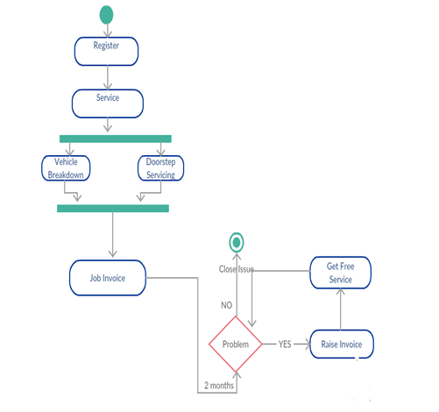

figure1: Activity Diagram for Wheelers Doctor

- Software Requirement Specifications
Actors and Description:
The actors in this project are:
- Mechanic
- Admin
- Customer
Description:
- Mechanic: The one who is sent by the admin and contacted by the customer. Each mechanic will have mechanic id. All the details of the mechanic will be displayed to the customer at the time of service request.
- Admin: The Admin is the actor who looks upon all the requests generated by the user or the customer and contacts customer and mechanic to ensure thatcustomer is not having any problem with the mechanic and mechanic isworking properly.
- Customer: Here comes the main actor. The entire process starts with the customer whoregisters with the website. Customer can request the service which can be doorstep or vehicle breakdown. The customer can also raise job invoice.
The use cases associated with the actors are Website, Mobile Number, Service Request, Doorstep, Vehicle Breakdown, Sends, Job Invoice, Contacts, Repairs or Services. The use cases associated with each actor are:
- Customer: Website, Service Request, Contacts, Job Invoice.
- Admin: Service Request, Sends, Contacts, Job Invoice.
- Mechanic: Sends, Repairs/Services, Contacts.

Use Case Diagram
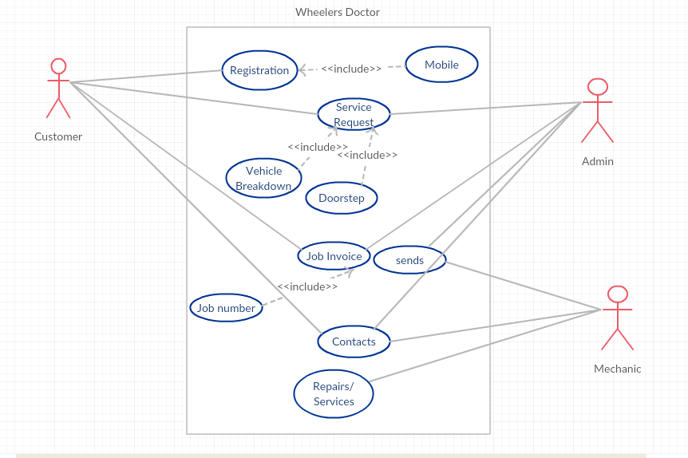
figure2: Usecase Diagram for Wheelers Doctor

The figure2 shows the usecase diagram of Wheelers Doctor and its actors and usecases.
3.1 Usecases for each actor

- Customer(Registration, Service Request, Contacts, Job Invoice):

The Customer is the actor to which the use cases Website, ServiceRequest, Contacts and Job Invoice are associated. Website is the use case which provides the user to register and get the account. The Website use case includes other use case known as “Mobile Number” which is to be given by the user at the time of registration. After registering the customer will make the service request shown by Service Request use case. Service Request use case includes two other use cases known as “Doorstep” and the other known as “Vehicle Breakdown”. Therefore, the customer can request for either doorstep service or vehicle breakdown service.
The other two use cases are “JobInvoice” and “Contacts”.Job Voice is an action which allows the user or customer to raise his complaint if he faces any problem in the area where the mechanic has worked within the duration of two months from the time the service has been attended. The complaint is raised by the job number the customer is given by the website at the time of service request. The customer or the user of the website gets the contact number (and the other details) of the mechanic after registering the service. The customer needs to contact the mechanic to get the service and this action is shown by Contacts use case. The figure3 shows the usecases for the actor Customer.

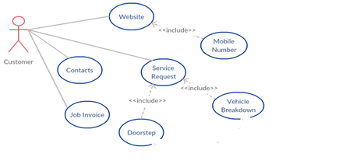
figure3: Usecases for Customer
- Admin (Service Request, Sends, Contacts, Job Invoice):

The admin actor deals with the use cases Service Request, Sends, Contacts, Job Invoice. The duty of this actor is to monitor the Service Request, Job Invoice, Contact the mechanic and customer to check if everything is going on properly and also to send the mechanic. Every service the customer requests and every “Job Invoice” the customer raised can be viewed by the admin. The complaint is raised by the job number the customer is given by the website at the time of service request. The admin “Contacts” the mechanic to know the status and also contacts the customer to make sure if the service has been received. With the raise of Job Invoice, the admin sends the mechanic again to repair or to attend the service. The figure4 shows usecases for the actor Admin
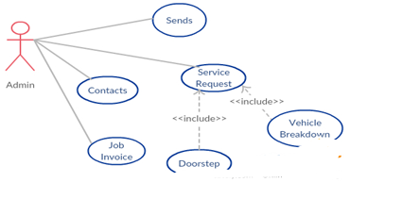
figure4: Usecases for Admin
- Mechanic (Sends, Repairs/Services, Contacts):

The actor mechanic is associated with the use cases Sends, Repairs/Services and Contacts. When the customer registers for a service request, the admin knows about the request and can contact the mechanic to send the mechanic to the customer. In this manner, the mechanic may be sent to the customer. This action is showed by the “Sends” use case. The customer can contact the mechanic to know the status and this action is showed by “Contacts” use case. The actor mechanic attends the service to service or repair the vehicle. Hence the use case “Repairs/Services” use case shows the action of repair or service to the vehicle by the actor mechanic. The figure5 shows the usecases for mechanic
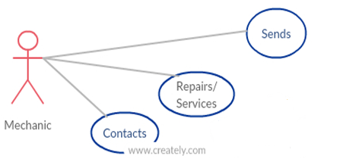
Figure5: Usecases for Mechanic

    - Parameters, Functions and flow chart for each file
Registration Page(register.php):
Flow Chart:
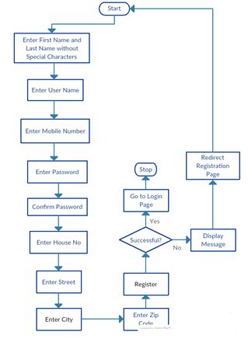
Figure6: Flow Chart for Registration Page
Parameters:
The parameters in registration page are:
- First Name
- Last Name
- User Name
- Mobile Number
- Enter Password
- Confirm Password
- House No
- Street
- City
- Zip Code

Function:
On entering the registration page the user is expected to enter First Name, Last Name and User Name without special characters. He/She is expected to enter 10 digit valid mobile number and the password. The user should enter his address( House No,Street,City,Zip Code). Failing the conditions does not create an account for the user and the page is reloaded with the unsuccessful message. If the account creation is successful, the user is redirected to login page.
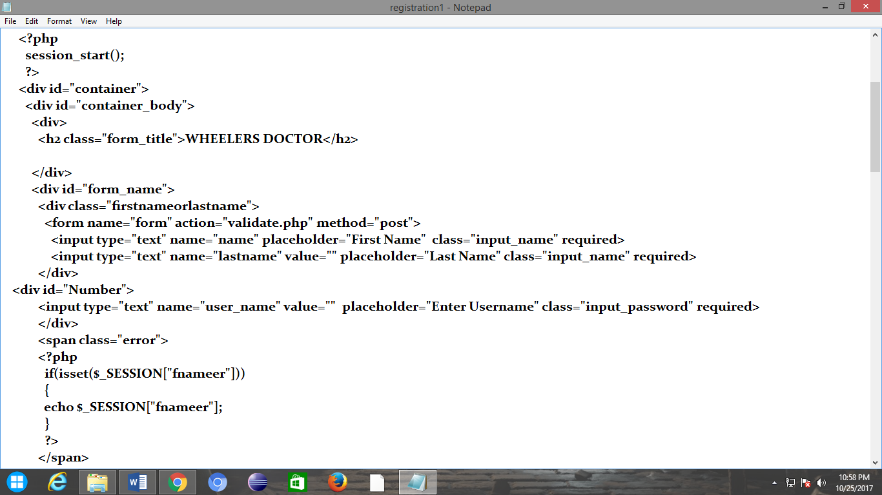

Login Page (login.php)
Flow Chart:

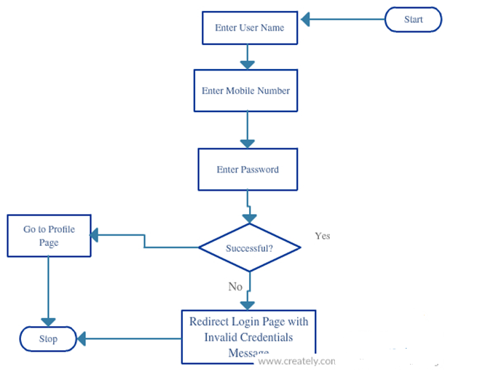

Figure7: Flow Chart for Login Page

Parameters:
The parameters in registration page are:
- User Name
- Mobile Number
- Enter Password

Function:
On entering into the login page, the user is expected to enter his User Name, Mobile Number and Password. If all the details are correct, then the user is redirected to his profile.
If the mentioned particulars are wrong, the login page is reloaded and the user is displayed “Invalid Credentials. Try Again.” Message.
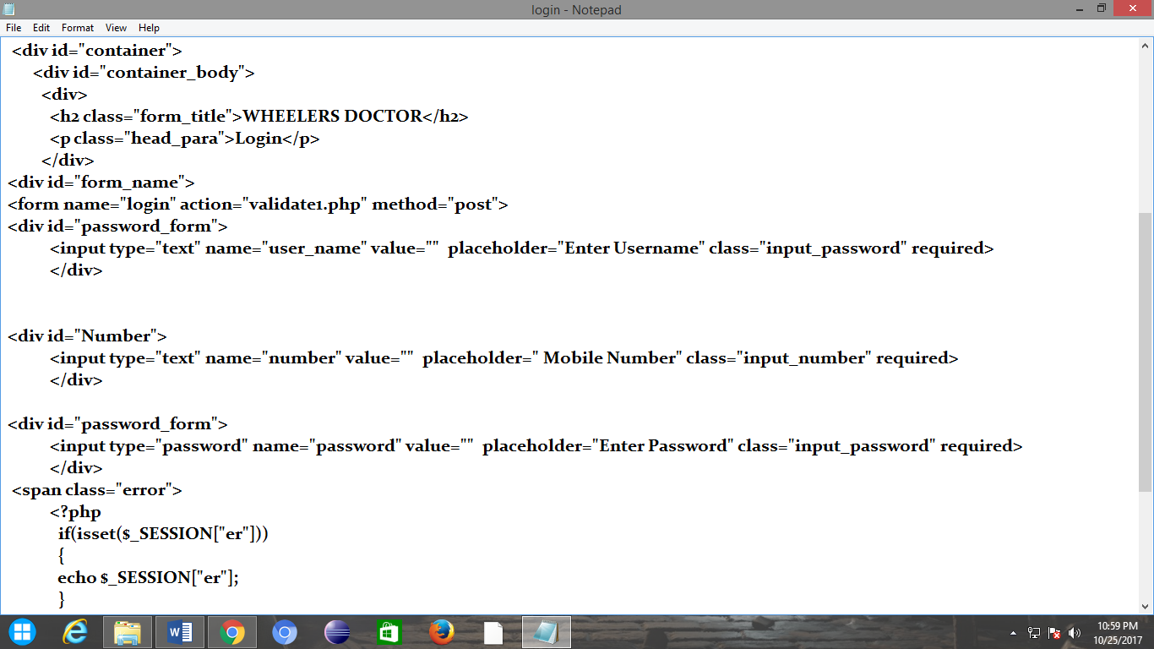
Profile Page(profile.php)
Parameters:
The parameters in Profile page are:
- User Name
- Iframe(Location)

Functions:
After successful login, the user is redirected to his profile. The username is stored in a session variable from the login page and is used here to display his username.
Based on the user name, House No, Street and city is retrieved and the location of the user is displayed using google maps.
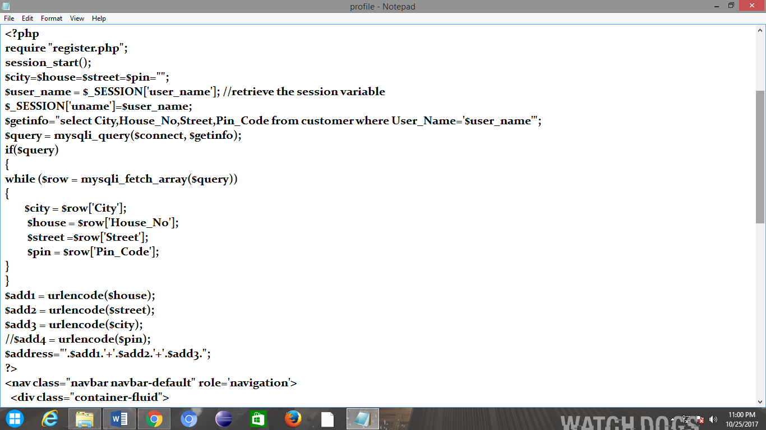
The figure 8 shows the flow chart for User Profile Page

Flow Chart:
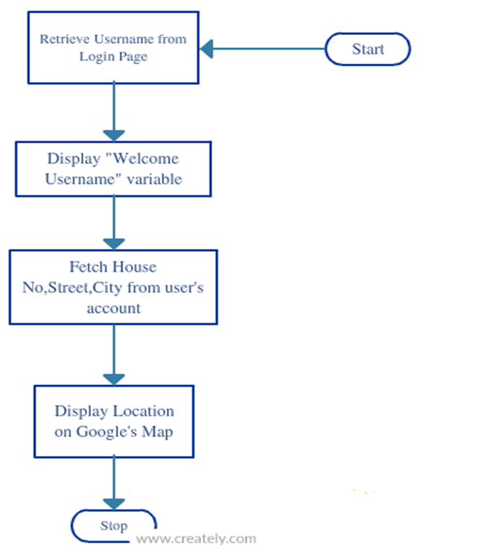
Figure8: Flow Chart for Profile Page

Doorstep Services
It consists of two pages: the one is form which asks the vehicle number and the other is the page which displays the mechanic information and mechanic location.
Vehicle Number Page:
Flow Chart:
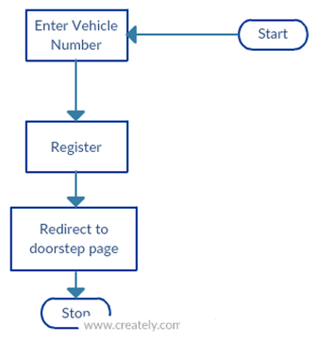
Figure9: Flow Chart for Vehicle Number Page

Parameters:
- Enter Vehicle Number

Functions:The user is expected to enter the vehicle number and click on register button. Once the button is clicked, the user is redirected to the page where the details of the mechanic is displayed i.e., doorstep page. It is illustrated in figure10.

Doorstep Page:
Flow Chart:
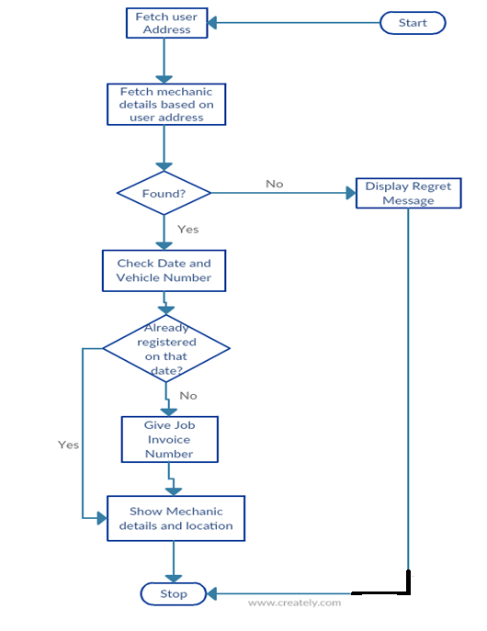
figure10: Flow Chart for Doorstep Page

Parameters:
The parameters involved are:
- User Address
- Mechanic Details
- Job Number
- Date

Function:
On selecting the doorstep services, the user is asked to enter his vehicle number as shown in the figure6 in the vehicle number page. After that, the user details is fetched from the database. Based on the user address the mechanic details is fetched. If there are no mechanics, the regret message “We regret to inform you that there are no mechanics nearby” is displayed.
Vehicles number and the date is checked. If the user registers the same vehicle number on the same date, the user is not given a job number and the mechanic details is displayed along with his location shown by google maps.
If the user has not registered with that vehicle number on that date, the user is given a job number and the nearby mechanic details is shown along with his location shown by google maps. It is illustrated in figure10.
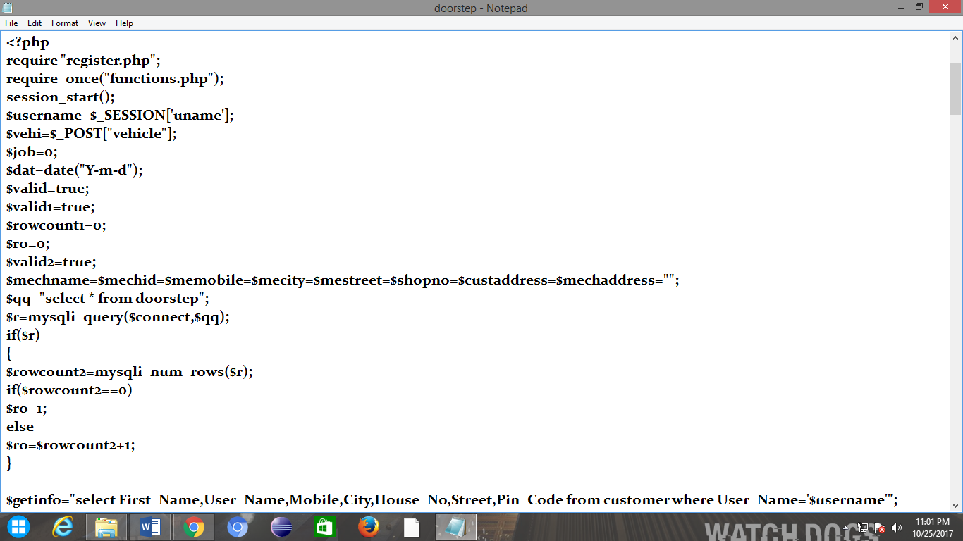
VehicleBreakdown:
Breakdown Address Page:
Parameters:
The parameters involved are:
- Vehicle Number
- Street
- City
- Zip Code
Functions:
In this page, the user is expected to fill the details like Vehicle number, Street, City and Zip code where the vehicle has been broke down and is redirected to the page showing mechanic details i.e., Vehicle Breakdown page.
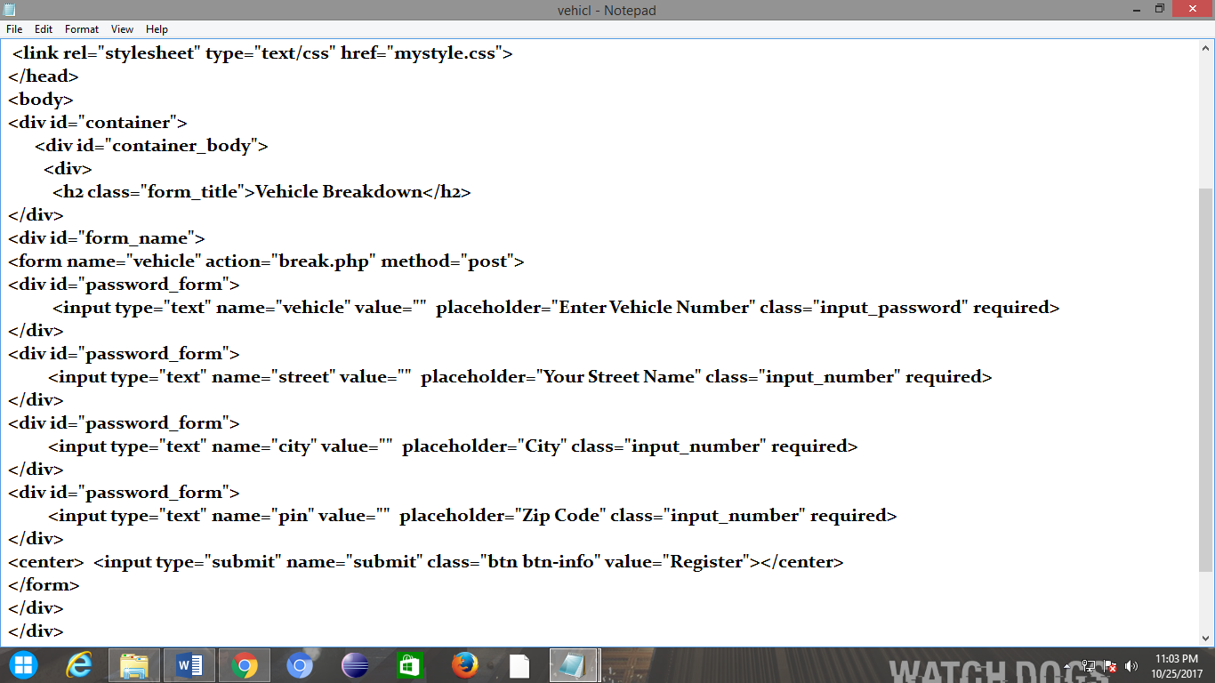

Flow Chart:

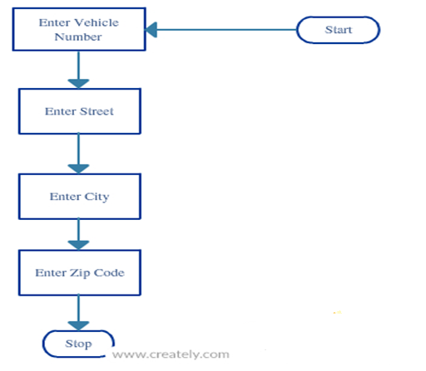
figure11: Flow Chart for Breakdown Address Page
Vehicle Breakdown Page (Mechanic Details):
Parameters:
The parameters involved are:
- Breakdown Address( Street, City, Zip Code)
- Vehicle Number
- Mechanic Details
- Job Number
- Date

Function:
On selecting the vehicle breakdown services, the user is asked to enter his vehicle number and break down address as shown in the figure8 in the breakdown address page. Based on the breakdown address the mechanic details is fetched. If there are no mechanics, the regret message “We regret to inform you that there are no mechanics nearby” is displayed.
Vehicles number and the date is checked. If the user registers the same vehicle number on the same date, the user is not given a job number and the mechanic details is displayed along with his location shown by google maps. If the user has not registered with that vehicle number on that date, the user is given a job number and the nearby mechanic details is shown along with his location shown by google maps. It is illustrated in figure13.
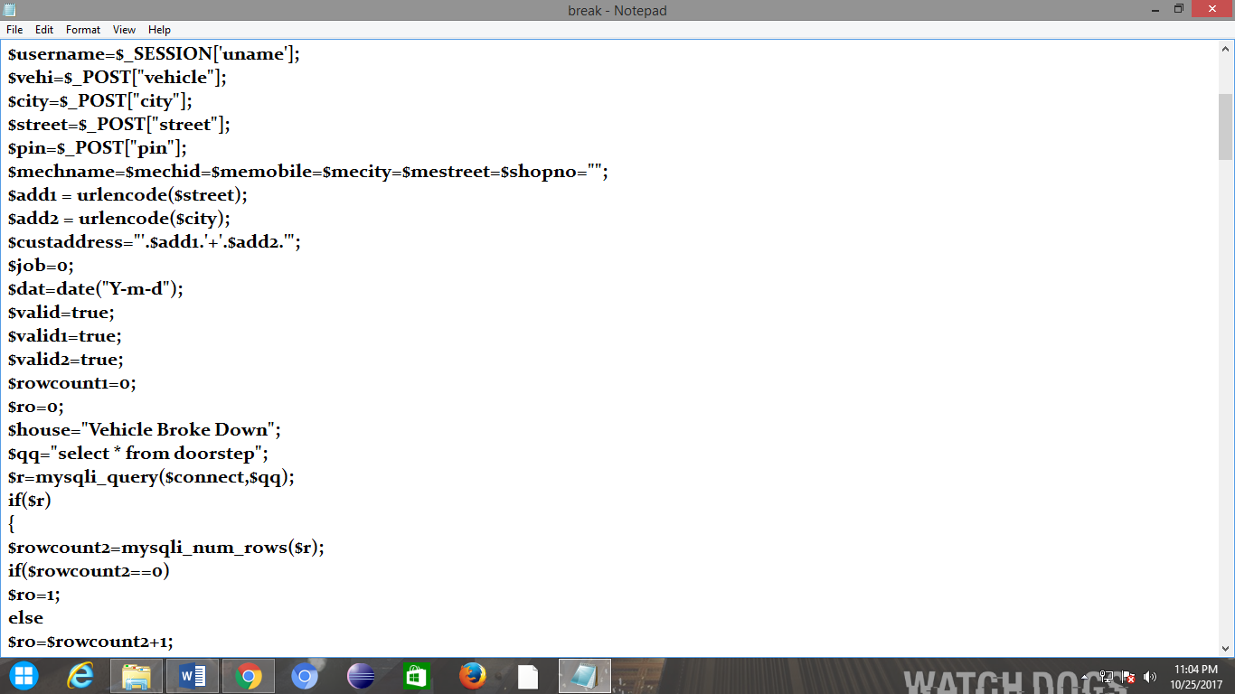

Flow Chart:

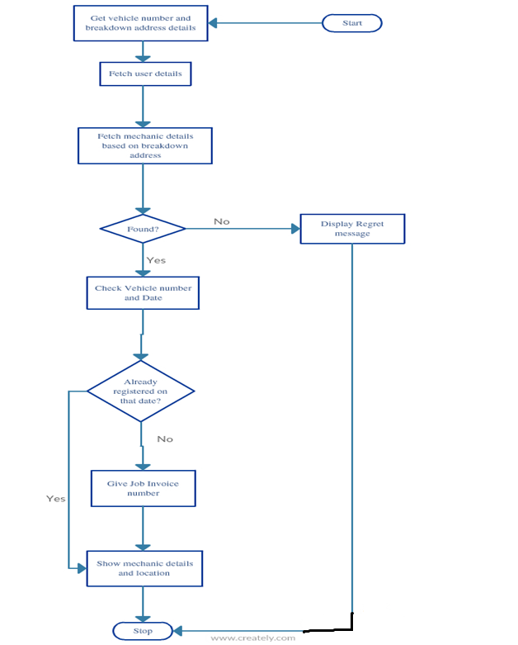
figure12: Flow Chart for Breakdown Page(Mechanic Details)

JobInvoice:
Parameters:
The parameters involved are:
- Job Number
- Problem

Function:
In this page, the user is expected to enter his job number and problem. If the job number is invalid or not found, it displays a message “Enter a valid job number”. If the number is valid, based on the job number the user details is fetched and shown.
On clicking the ‘Complaint’ button, it displays a message “Successfully Registered. Mechanic will contact you soon”. The figure 14 Flow chart for Job Invoice page shows the functionality of Job Invoice page.
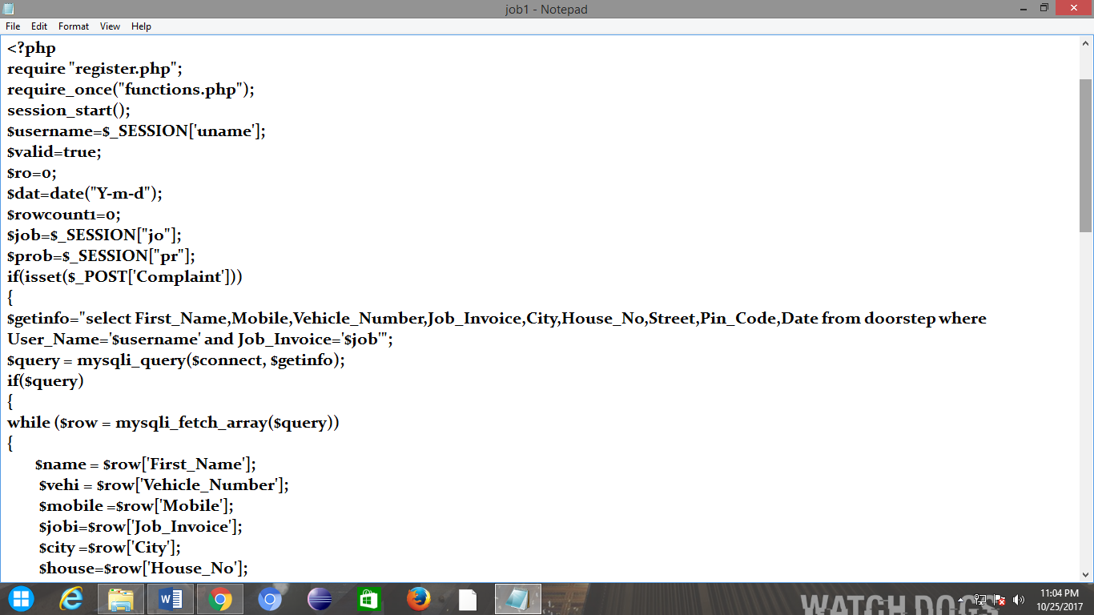

Flow Chart:

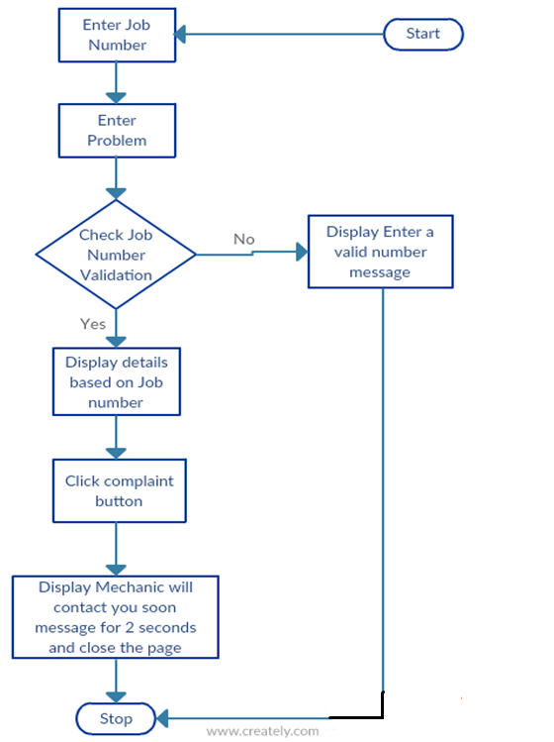
figure13: Flow Chart for Job Invoice Page
Logout:
Parameters:
- Sessionvariableusername
Flow Chart:
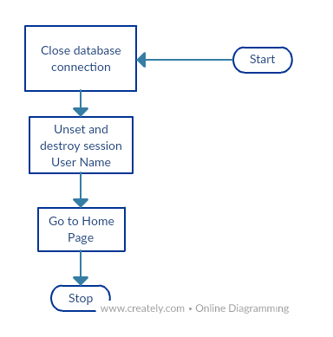
figure14: Flow Chart for Logout Page
Function:
When the user logs out, the database connection is closed, the session variable user name is unset and is destroyed. It is illustrated in figure14.
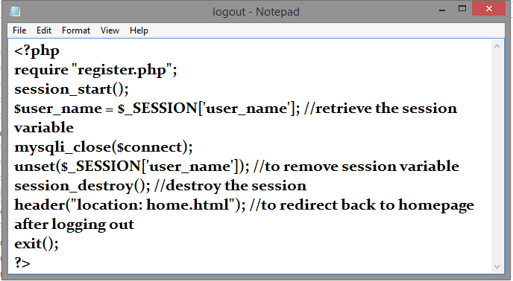
AdminLogin:
Parameters:
The parameters involved are:
- AdminName
- Admin Password
Function:
If the admin name and admin password are valid, it is redirected to admin profile. It is illustrated in figure15.
Flow Chart:

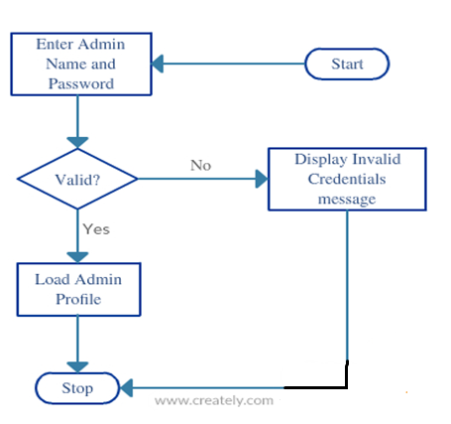
figure15: Flow Chart for Admin Login Page

AdminProfile:
Parameters: The parameters involved are:
- UserDetails(Customer Name, Mobile Number, Address)
- Mechanic Details( Mechanic Name, ID, Mechanic Mobile)
- Service Details( Job Number, Date)

Function:
In admin profile, the details of the user and the mechanic details and the service details are displayed to the admin. It is illustrated in figure16.

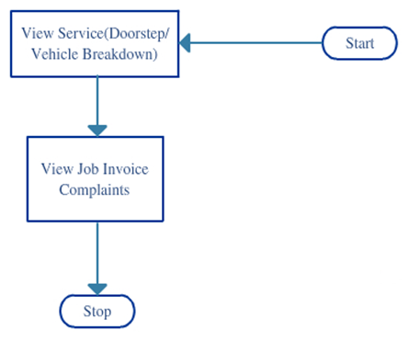
figure16: Flow Chart for Admin Profile Page

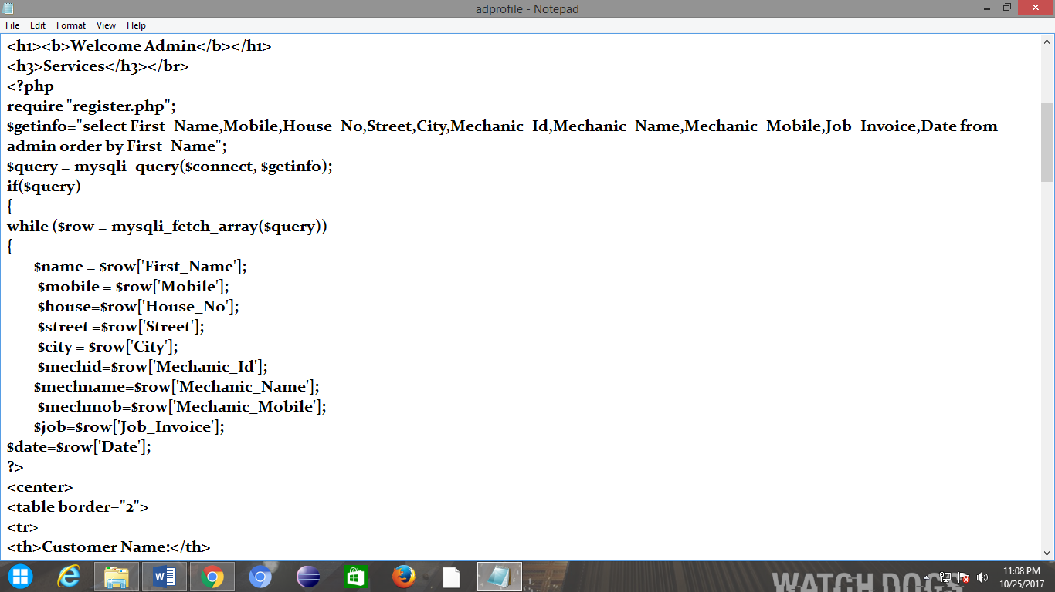

3.1.3 User Manual for each Usecase
The usecases associated in this project are:
- Registration which includes the other use case Mobile Number
- Service Request which includes the usecases Doorstep and Vehicle Breakdown
- Sends
- Job Invoice which includes the usecase Job Number
- Contacts
- Repairs/Services

Registration:
Through the Wheelers Doctor website the customer or the user registers and using the username and mobile number through which he registers he/she can login. After logging in, the user can request for services like Doorstep and VehicleBreakdown. The website use case includes other usecase Mobile Number mainly used later for interaction between mechanic and customer and the communication between admin and customer. Doorstep and Vehicle Breakdown and their functionalities are explained in the Service Request usecase section where the service request includes Doorstep and Vehicle Breakdown usecase. However, in this section we will have a glimpse. Doorstep Services are the services a customer or a user of website can get at his/her home where the mechanic goes to the home of the customer for normal bike servicing and mechanic may take the vehicle to his shed too. It is useful when the users/customers don’t find time to get their vehicle serviced.
Vehicle Breakdown is the main characteristic feature of this website. The user finds it useful when the vehicle stops in the middle of riding. All the user has to do is request for Vehicle Breakdown service where he will be asked for the location and on registering the user gets the nearby mechanic information and the service.The figure 18 shows the usecase for Website.
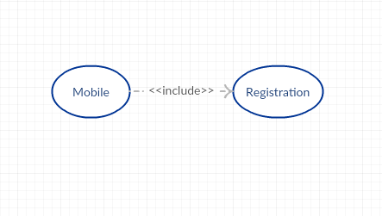
figure17: Usecase for Registration

Service Request:
After logging in the user can request for the service. This usecase ServiceRequest includes two main use cases: VehicleBreakdown and DoorstepServices. DoorstepService is useful when users/customers don’t find time to get their vehicle serviced. On registering with the doorstep service, the service is right at user’s footstep. Another important usecase to be discussed here is VehicleBreakdown.
While driving sometimes it can happen that the vehicle will stop for few reasons. In such cases Vehicle Breakdown plays an important role. On selecting it, the user is asked for the address where the vehicle has stopped. On entering it, the nearby mechanic details is shown to the customer and the customer can contact the mechanic. The figure18 shows the usecase for Service Request.
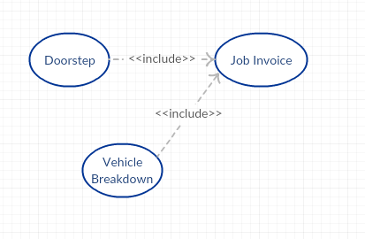
figure18: Usecase for Service Request

Sends:
The usecase represents the action where the admin contacts the customer to know if the services has received. If not, the admin contacts the mechanic to know the status and sends the mechanic and makes sure that the customer gets the service. The figure 19 shows the usecase for sends.
Sends

Figure19: Usecase for Sends

Job Invoice:
The usecase JobInvoice includes another usecase JobNumber. Through Job Invoice, the customer can raise or report a complaint if the customer faces any problem in the area where the mechanic has worked within two months from the date the service has been attended and get the free service. Now the question is how a user can raise a complaint.
On registering for the service, the user is shown a Job Number which should be noted by the user which contains all the details of the user and with this job number, the user can raise or report a complaint if the customer faces any problem in the area where the mechanic has worked within two months from the date the service has been attended and get the free service. The figure 20 shows the usecase for job invoice which includes job number.
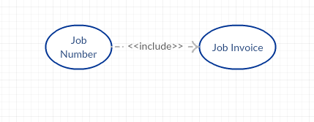
figure20: Usecase for Job Invoice
Contacts:
When the user or a customer registers for a service the details of the user and his mechanic are displayed on the admin page. The usecase Contacts represents the action where the admin contacts both the user, and the mechanic. The admin contacts the user to know if everything is fine and the customer is free from the problem and also contacts the mechanic to know if the mechanic has attended the service and to confirm the status. The figure 21 shows the usecase for Contacts.
Contacts

figure21: Usecase for Contacts.
Repairs/Services:
As explained above, the user requests for Doortep Services or Vehicle Breakdown Services. After requesting for the service, this usecase represents the action of repairing or servicing the vehicle by the actor mechanic. The figure 22 shows the usecase for Repairs/Services.
Repairs/Services

figure22: Usecase for Repairs/Services

4. Database Design
In this project of Wheelers Doctors, the database has tables namely:
- Customer
- Doorstep Services
- Mechanic
- Admin
- Admin1
- Job_Invoice
Customer ( First_Name, Last_Name, User_Name, Mobile, Password,City, House_No, Street, Pin_code):
For customer table we have attributes: First_Name varchar(20), Last_Name varchar(20), User_Name varchar(20), Mobile text, Password varchar(20), City varchar(20), House_No varchar(100), Street varchar(25), Pin_Code text. It is illustrated in table1 and figure23.
For example:
In this table, the username is the primary key and holds unique for every customer. Whatever details, the customer enters, those details are stored in this customer table.

Attribute | Type
First_Name | varchar(20)
Last_Name | varchar(20)
User_Name | varchar(20)
Mobile | text
Password | varchar(20)
City | varchar(20)
House_No | varchar(100)
Street | varchar(20)
Pin_Code | text
Table1: Customer Table
Password
First_Name
City

House_No
Customer
Last_Name
Street
Mobile
Pin_Code
User_Name

figure23: Customer table and attributes
Doorstep (First_Name, House_No, City, Mobile, Last_Name, User_Name, Pin_Code, Date, Vehicle_Number, Street):
Regardless of the service type of request by the user i.e., either Doorstep or Vehicle Breakdown, the requests and the user details are stored in this table(Table2 and figure24)
Attribute | Type
First_Name | varchar(20)
House_No | varchar(100)
City | varchar(20)
Mobile | text
Last_Name | varchar(20)
User_Name | varchar(20)
Pin_Code | varchar(20)
Date | date
Vehicle_Number | text
Street | varchar(20)

Table2: Doorstep Table
City
House_No
Mobile
Pin_Code
User_Name
Street
Date
Vehicle_Number
Last_Name
First_Name
Doorstep

figure24: Doorstep table and attributes
Admin (First_Name, House_No, City, Mobile, Street, Mechanic_Name, Mechanic_id, Mechanic_Mobile, Job_Invoice, Date):
For admin table we have attributes: First_Name, Mobile, City, House_No, Street, Mechanic_Name, Mechanic_id, Mechanic_Mobile, Job_Invoice and Date. This table gets entered whenever the user makes a service request and the details are viewed to the admin from this table. Illustrated in table3 and figure 25.

Mechanic_Name
City
House_No
First_Name
Street
Mobile
Date
Admin

Mechanic_Mobile
Job_Invoice
Mechanic_Id

figure25: Admin table and attributes

Attribute | Type
First_Name | varchar(20)
House_No | varchar(100)
City | varchar(20)
Mobile | text
Mechanic_Name | varchar(20)
Mechanic_Mobile | varchar(20)
Mechanic_Id | integer
Date | date
Job_Invoice | integer
Street | varchar(20)

Table3: Admin Table
Admin1(First_Name, House_No, City, Mobile, Street, Mechanic_Name, Mechanic_id, Mechanic_Mobile, Job_Invoice, Date):
For admin1 table we have attributes: First_Name, Mobile, City, House_No, Street, Mechanic_Name, Mechanic_id, Mechanic_Mobile, Job_Invoice and Date. This table gets entered whenever the user makes a complaint using Job Invoice number and the details are viewed to the admin from this table. Illustrated in figure26 and table4.

Mechanic_Name
City
House_No
First_Name
Mobile
Date
Admin1
Street
Mechanic_Mobile
Mechanic_Id
Job_Invoice
figure26: Admin1 table and attributes

Attribute | Type
First_Name | varchar(20)
House_No | varchar(100)
City | varchar(20)
Mobile | text
Mechanic_Name | varchar(20)
Mechanic_Mobile | varchar(20)
Mechanic_Id | integer
Date | date
Job_Invoice | integer
Street | varchar(20)

Table4: Admin1 Table
Mechanic (Mech_Name, Mech_Id, Shop_No, Street, City, Mobile, Near, Near1, Near2, Near3, Near4):
For mechanic table we have attributes: Mech_Name, Mech_Id, Shop_No, Street, City, Mobile, Near, Near1, Near2, Near3, and Near4. This table contains the mechanic details which is to be displayed to the user and using the near1, near2, near3, near4, and near attributes the user can contact the nearby mechanics. Illustrated in figure 27 and table5.
Mech_Id
Mobile
Near4
4

Shop_No
Street
Mech_Name
Near3

Near
City
Mechanic

Near2

Near1

figure27: Mechanic table and attributes
Attribute | Type
Mech_Id | Integer
Shop_No | varchar(100)
Mech_Name | varchar(20)
Near | varchar(50)
Near1 | varchar(50)
Near2 | varchar(50)
Near3 | varchar(50)
Near4 | varchar(50)
City | varchar(20)
Street | varchar(20)
Mobile | Text
Table5: Mechanic Table
JobInvoice( First_Name, Job_Invoice, Mobile, City, House_No, Street, City, Pin_Code, Vehicle_Number, User_Name, Problem, Date):
For Job_Invoive table we have attributes: First_Name, Job_Invoice, Mobile, City, House_No, Street, City, Pin_Code, Vehicle_Number, User_Name, Problem and Date. If a customer faces a problem in the area where the mechanic has worked within the two months from the date of service he/she can report a complaint through Job_Invoice number and get the free service.
House_No
User_Name
City
Date
First_Name
Job_Invoice
JobInvoice
Problem
Mobile
Pin_Code
Street

figure28: JobInvoice table and attributes
Vehicle_Number

Attribute | Type
First_Name | varchar(20)
User_Name | varchar(20)
City | varchar(20)
Date | Date
House_No | varchar(20)
Mobile | Text
Job_Invoice | Integer
Pin_Code | Integer
Problem | varchar(100)
Vehicle_Number | varchar(20)
Street | varchar(20)
Table6:Job Invoice Table
Relationships:

Admin
Mechanic
Customer

Doorstep

Figure29: Admin, Customer, Mechanic and doorstep relationships
The Admin table contains the information from Customer, Mechanic and Doorstep tables. Customer attributes are shown in Table1 and figure24. Mechanic attributes are shown in Table5 and figure29. Doorstep attributes are shown in Table2 and figure25. Admin attributes are shown in Table3 and figure25. The figure29 shows the relationship between Admin, Customer, Mechanic and Doorstep.

Admin1
Mechanic
Customer

JobInvoice

figure30: Admin1, Customer, Mechanic and JobInvoice relationships
The Admin1 table contains the information from Customer, Mechanic and JobInvoice tables.Customer attributes are shown in Table1 and figure23. Mechanic attributes are shown in Table5 and figure27. Job Invoice attributes are shown in Table6 and figure28. Admin1 attributes are shown in Table4 and figure26. The figure30 shows the relationship between Admin1, Customer, Mechanic and Job Invoice relationships.

5. Test Cases

Test Case Id | Test Case | Functions being tested | Initial State | Input | Output | Status
1 | Register | Accept Details | Home Page | Enter Details | Successful | Successful
2 | Login | Verify Username,Password and Mobile Number | Home Page | Enter Details | Login Successful | Successful
3 | Doorstep Services | Verify if already registered on that day | Profile | Vehicle number | Mechanic Details and Location | Successful
4 | Vehicle Breakdown | Verify if already registered on that day | Profile | Breakdown address and vehicle number | Mechanic Details and Location | Successful
5 | Job Invoice | Verify Job number | Profile | Job number and Problem | Succesfully registered message | Successful
6 | Logout | User Session end | Profile | - | Home Page | Successful

6. Screenshots
1. Home Page:
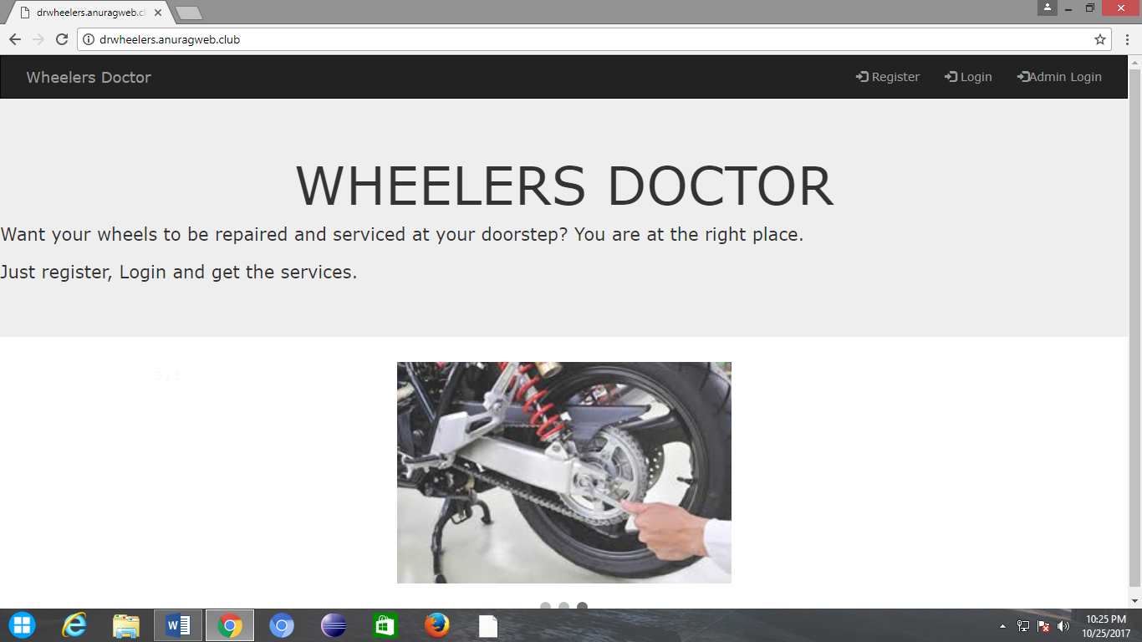
2. Registration Page:
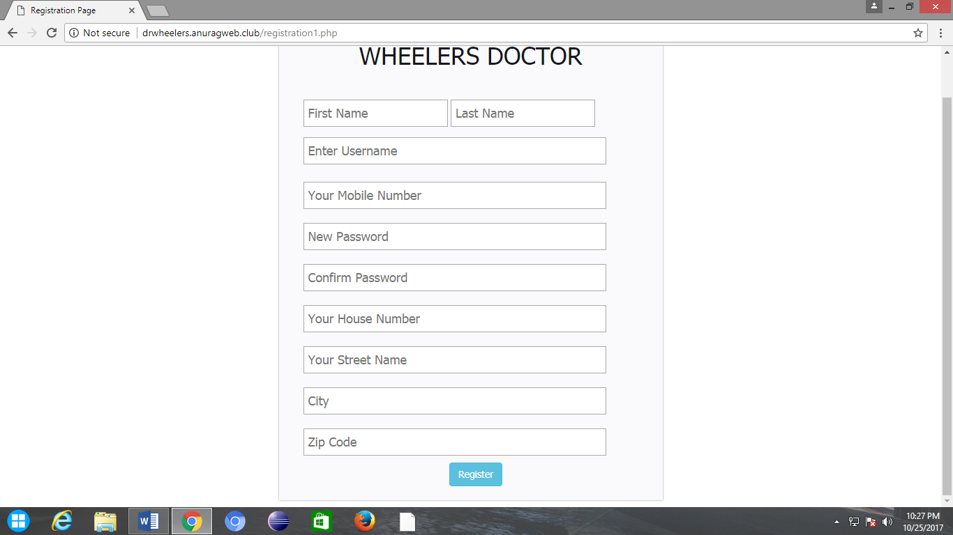

3. Login:
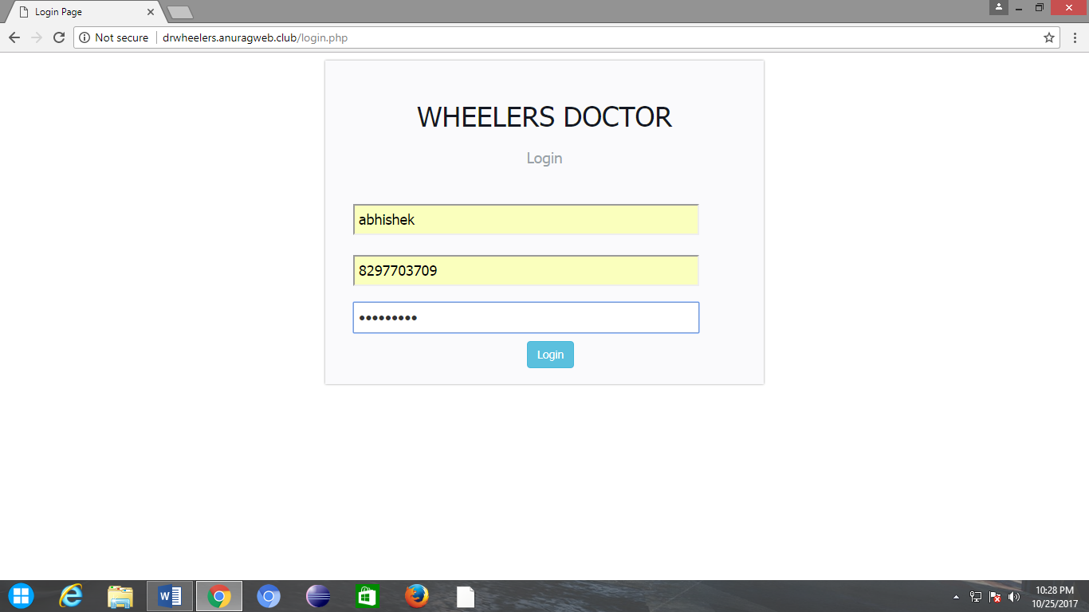
4. Profile:
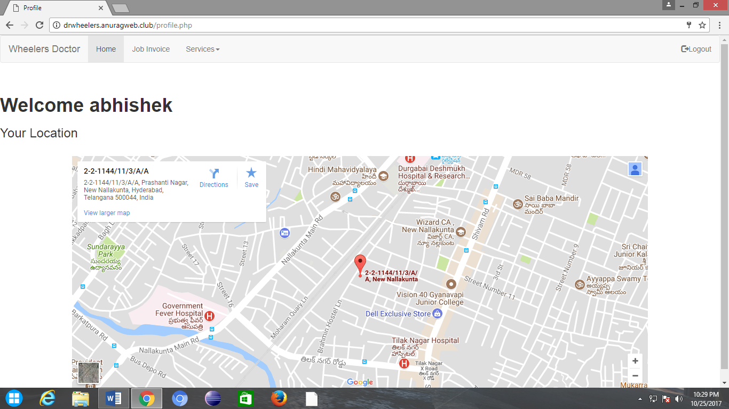

5. Doorstep:
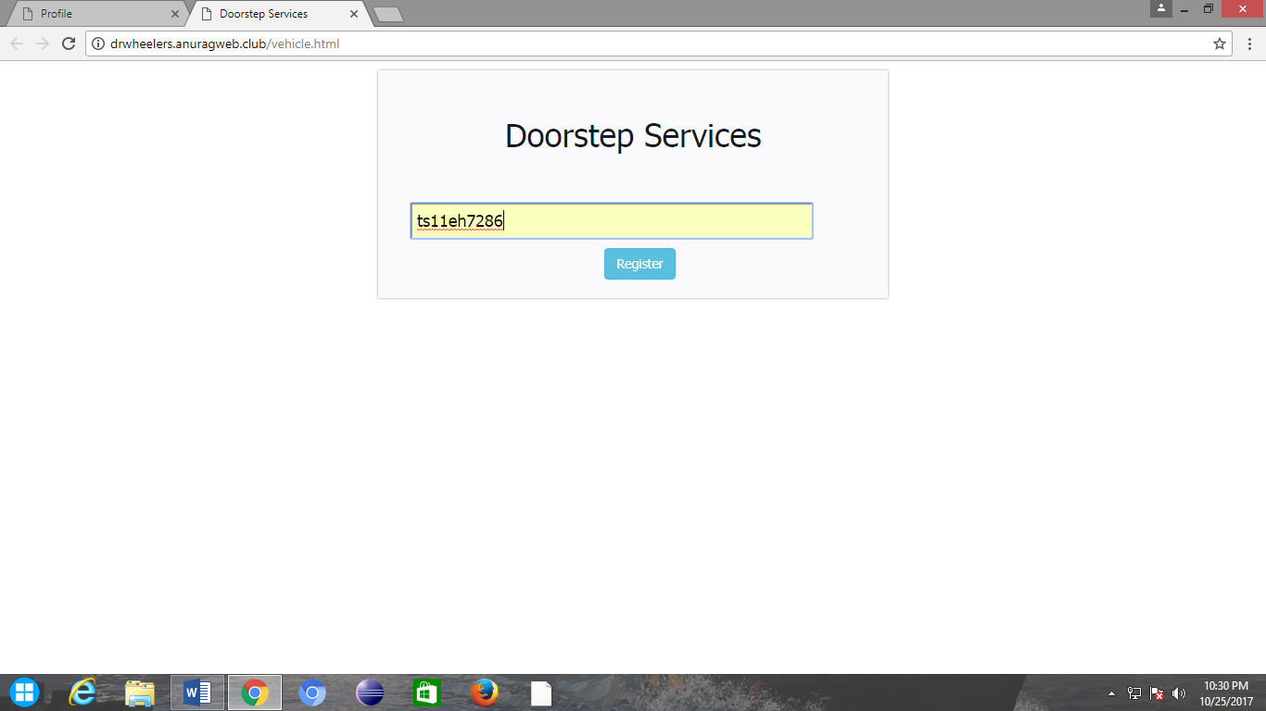

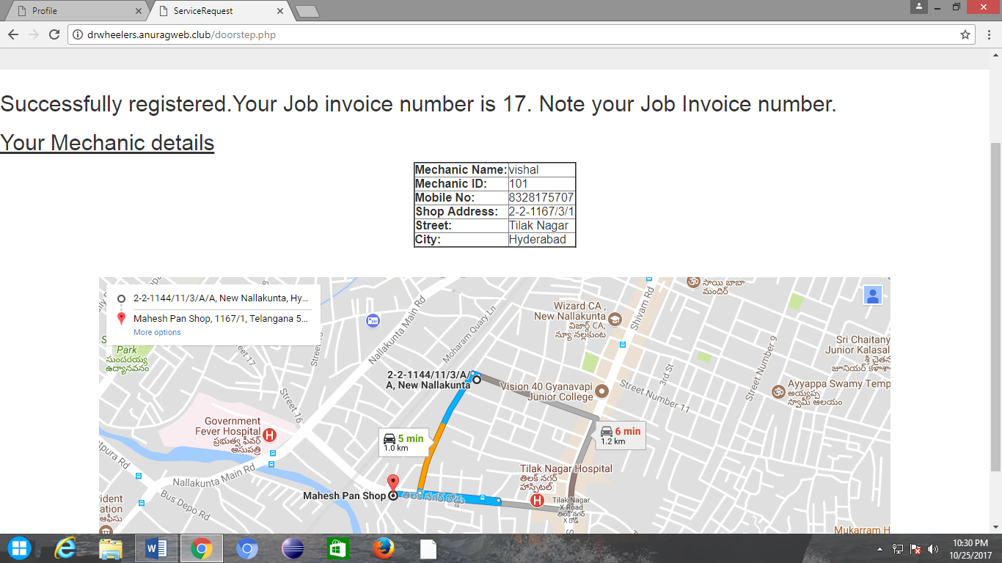
6. Vehicle Breakdown:
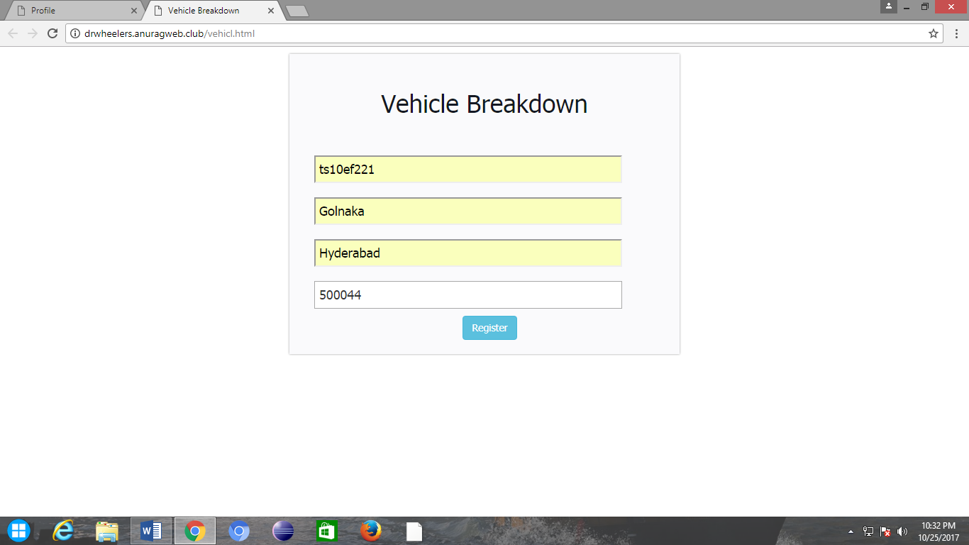

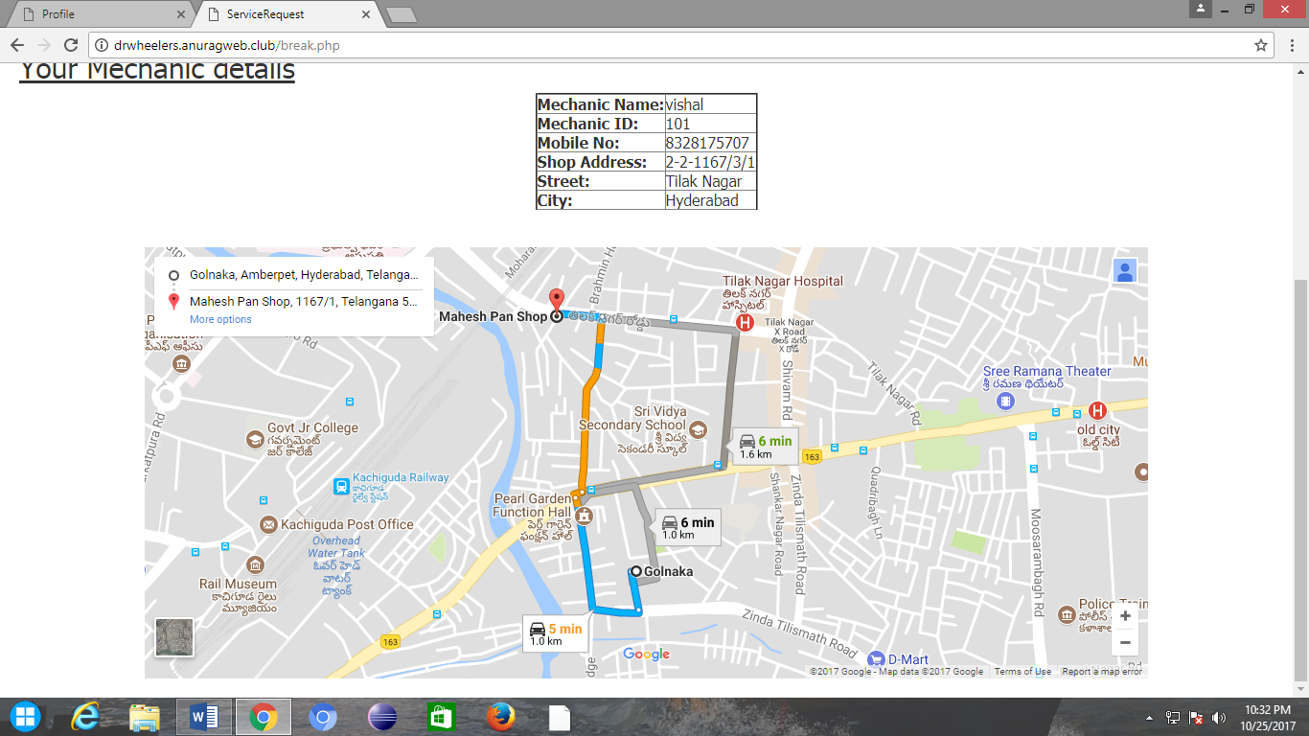

7. Job Invoice:
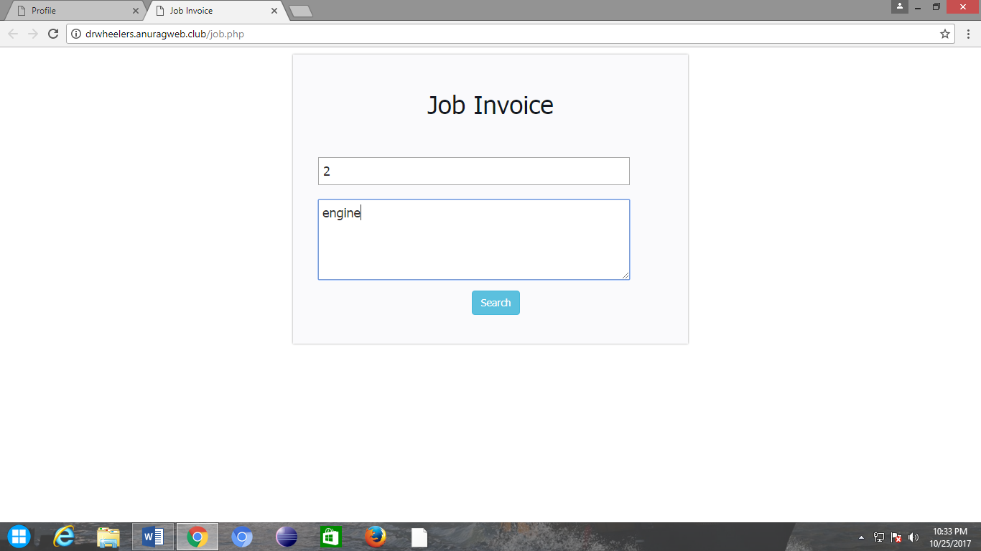

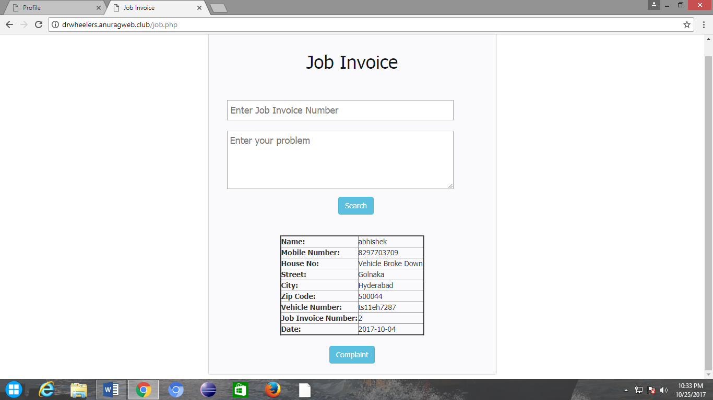

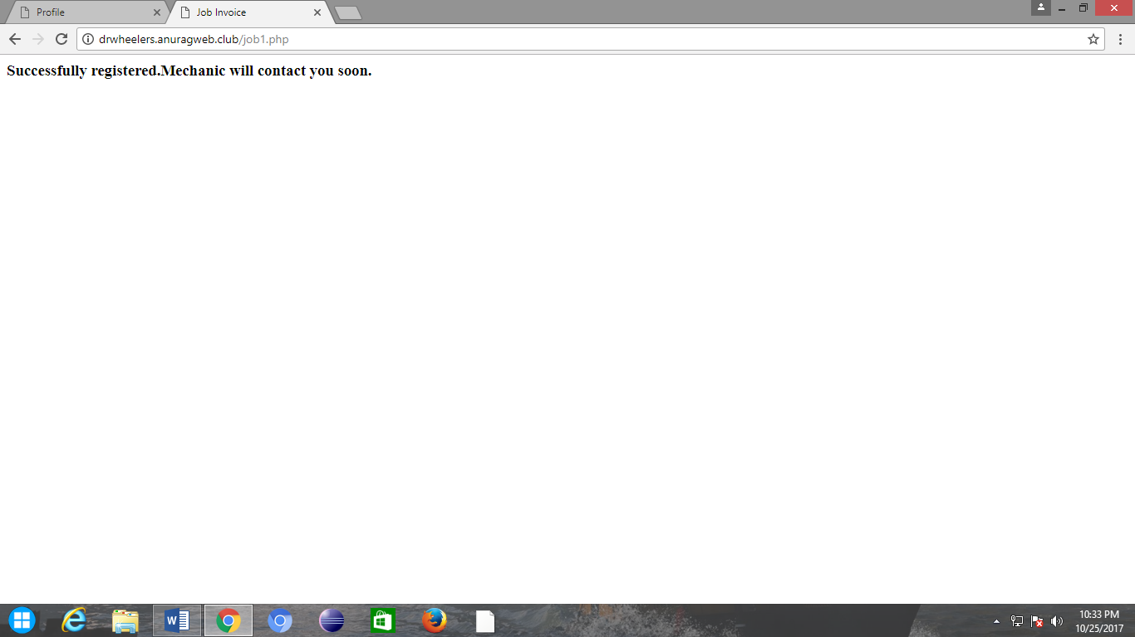
8. Logout:

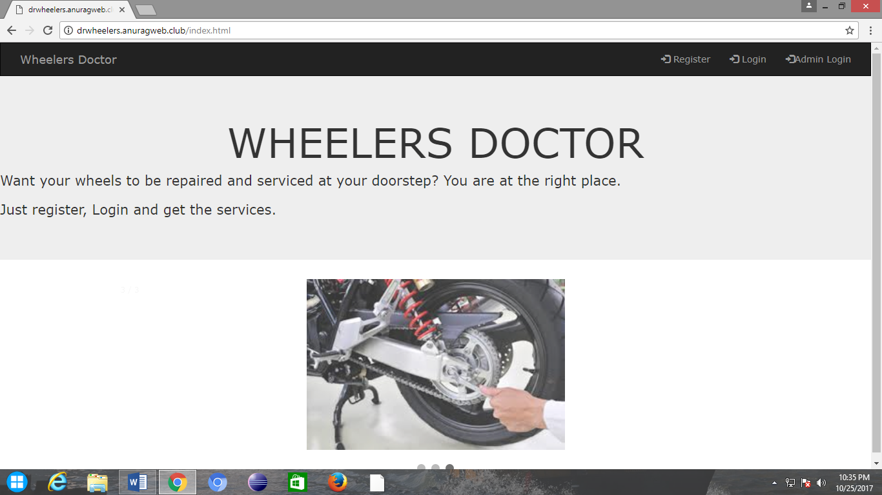

9. Admin Login:
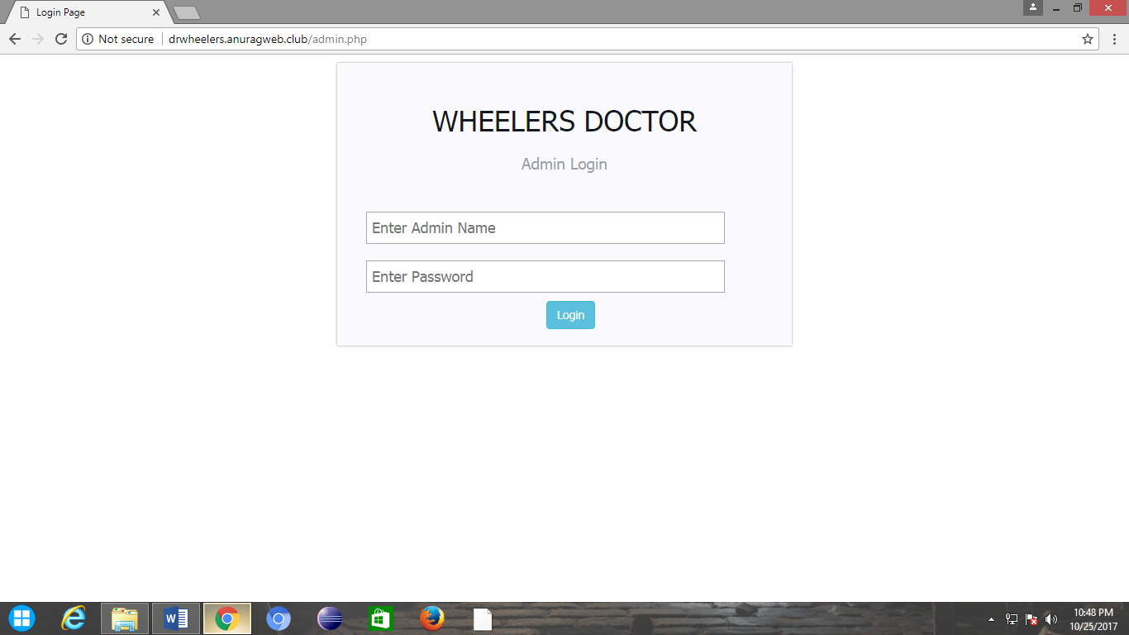
10. Admin Profile
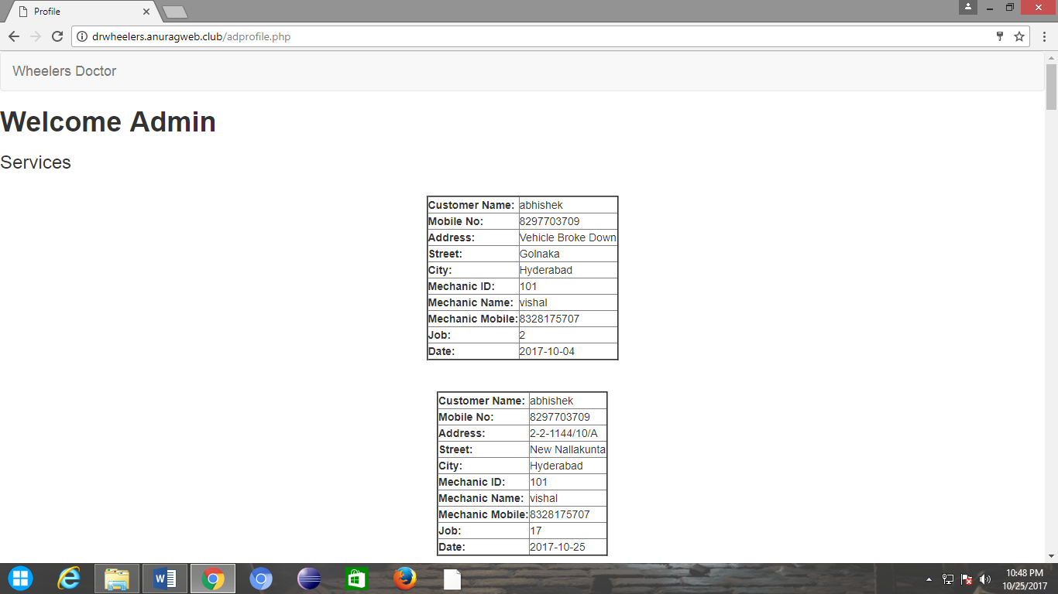

7. Deployment Diagram
The figure32 shows the deployment diagram for Wheelers Doctor. The nodes are:
WheelersDoctor:
This node performs following functions:
- Registration: Allows the user to register.
- Login: For user log in.
- Service: To request the service (Doorstep or Vehicle Breakdown)
- Admin: To view the services.
- Job Invoice: A number through which the user can get the free service if the problem occurred within the 2 months from the date of service.
Service:
This node is associated with a component mechanic. This node functions are:
- Doorstep Service:Services at doorstep.
- Service: Vehicle Breakdown Services.
Registration:
The function is:
- Add User: User Registration. To add a new user to wheelers Doctor. It requires a component user.

Login:
The functions are:
- Account Access: To login and access the account.
- Register Service: To request the service (Doorstep and vehicle breakdown).
Admin: The functions are:
- Look Services: To view the services (Doorstep and vehicle breakdown) and check status.
- Contact Mechanic: To contact the mechanic and check status.
- Contact Customer: To contact the customer and check status.

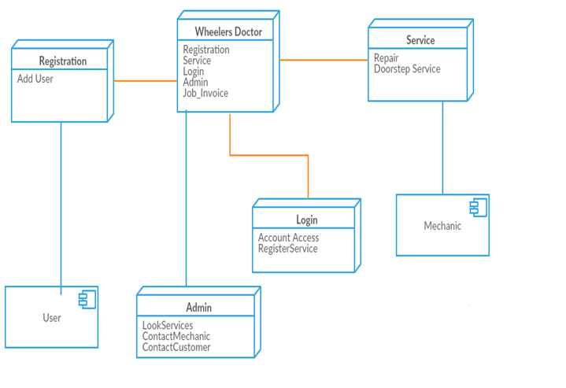
figure32: Deployment Diagram for Wheelers Doctor

8. Conclusion
Hence, this website is designed to help the users by providing the nearby mechanic details and their location. The users who may not find the time to service the vehicle may just register and the rest will be taken care by the website. This website is a great help for those whose vehicle breakdown in the middle of the travel. The user will get the nearby mechanic’s details. In addition, this website also adds job invoice feature, through which the user can get the free service if any problem occurred in the area where mechanic has worked within the 2 months from the date of service. Admin plays the key role in monitoring everything.

